**Analytic Query 1**

SELECT L.Location_Name,T.Time_Year,T.Time_Month,

SUM ( J.Quantity_Ordered * J.Unit_Price ) TotalJobAmount,

SUM ( SUM ( J.Quantity_Ordered * J.Unit_Price ) )

OVER ( PARTITION BY L.Location_Name,T.Time_Year

ORDER BY T.Time_Month

ROWS UNBOUNDED PRECEDING ) CumulativeSumAmount

FROM W_Job_F J,W_Location_D L,W_Time_D T

WHERE L.Location_Id = J.Location_Id

AND J.Contract_Date = T.Time_Id

GROUP BY L.Location_Name,T.Time_Year,T.Time_Month;

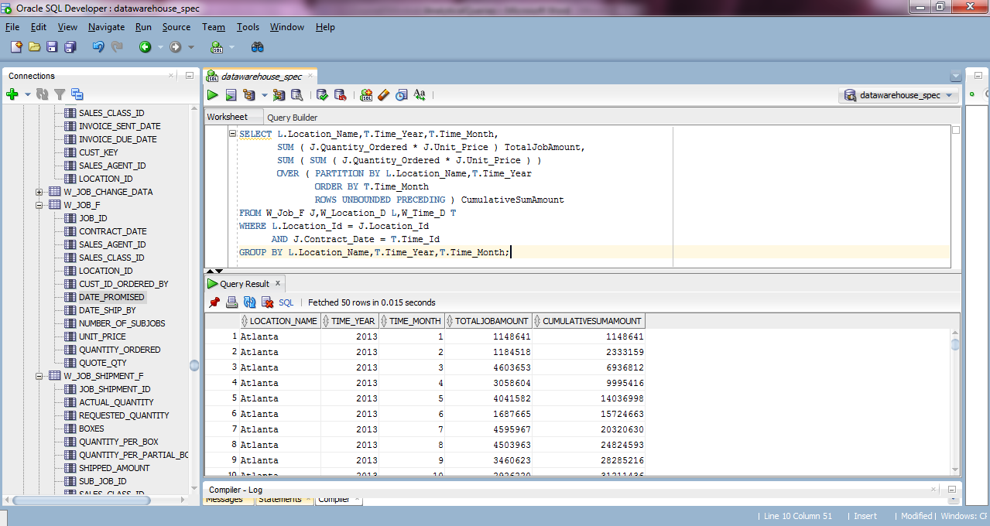

**Analytic Query 2**

SELECT L.Location_Name, T.Time_Year, T.Time_Month,

AVG( J.Quantity_Ordered * J.Unit_Price ) AvgJobAmount,

AVG( AVG( J.Quantity_Ordered * J.Unit_Price ) )

OVER ( PARTITION BY L.Location_Name

ORDER BY T.Time_Year,T.Time_Month

ROWS BETWEEN 11 PRECEDING AND CURRENT ROW ) MovingAvgAmtOrd

FROM W_Job_F J,W_Location_D L,W_Time_D T

WHERE J.Location_Id = L.Location_Id

AND J.Contract_Date = T.Time_Id

GROUP BY L.Location_Name,T.Time_Year,T.Time_Month;

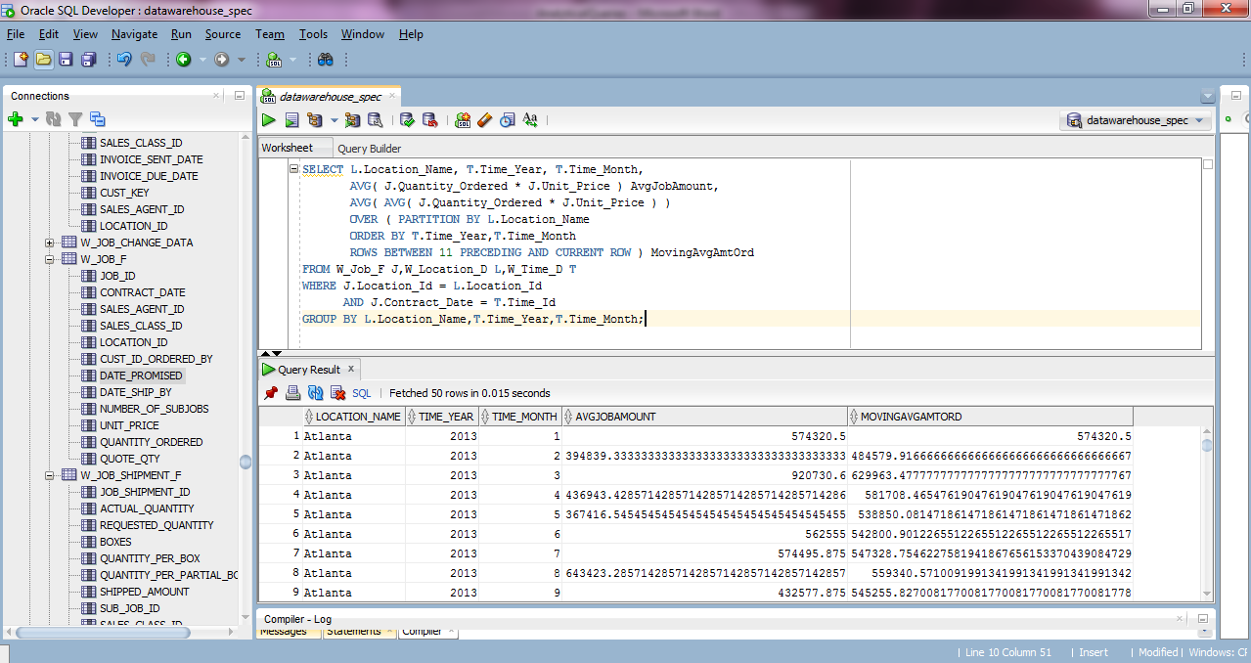

**Analytic Query 3**

SELECT X1.Location_Name,X1.Time_Year,

SUM(TotalInvoiceAmount-TotalCost) TotalLocationProfit,

RANK() OVER(PARTITION BY X1.Time_Year

ORDER BY(SUM(TotalInvoiceAmount-TotalCost)) DESC) RankProfit

FROM LocationSubjobCostSummary X1,LocationInvoiceRevenueSummary X2

WHERE X1.Job_Id=X2.Job_Id

GROUP BY X1.Location_Name,X1.Time_Year;

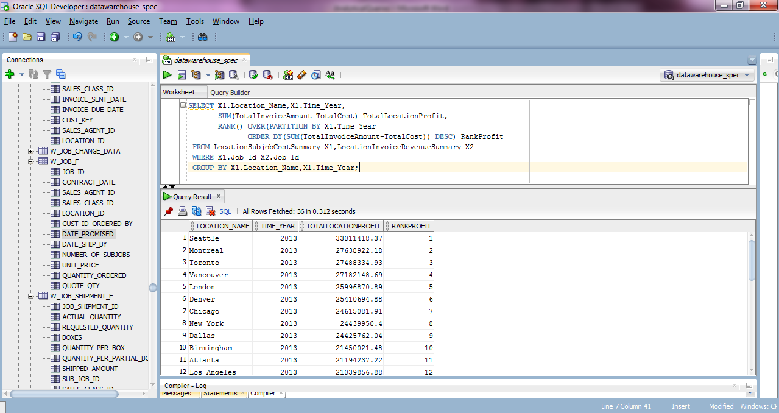

**Analytic Query 4**

SELECT X1.Location_Name,X1.Time_Year,

SUM(TotalInvoiceAmount-TotalCost)/SUM(TotalInvoiceAmount) ProfitMargin,

RANK() OVER(PARTITION BY X1.Time_Year

ORDER BY(SUM(TotalInvoiceAmount-TotalCost)/SUM(TotalInvoiceAmount)) DESC) RankProfitMargin

FROM LocationSubjobCostSummary X1,LocationInvoiceRevenueSummary X2

WHERE X1.Job_Id = X2.Job_Id

GROUP BY X1.Location_Name,X1.Time_Year;

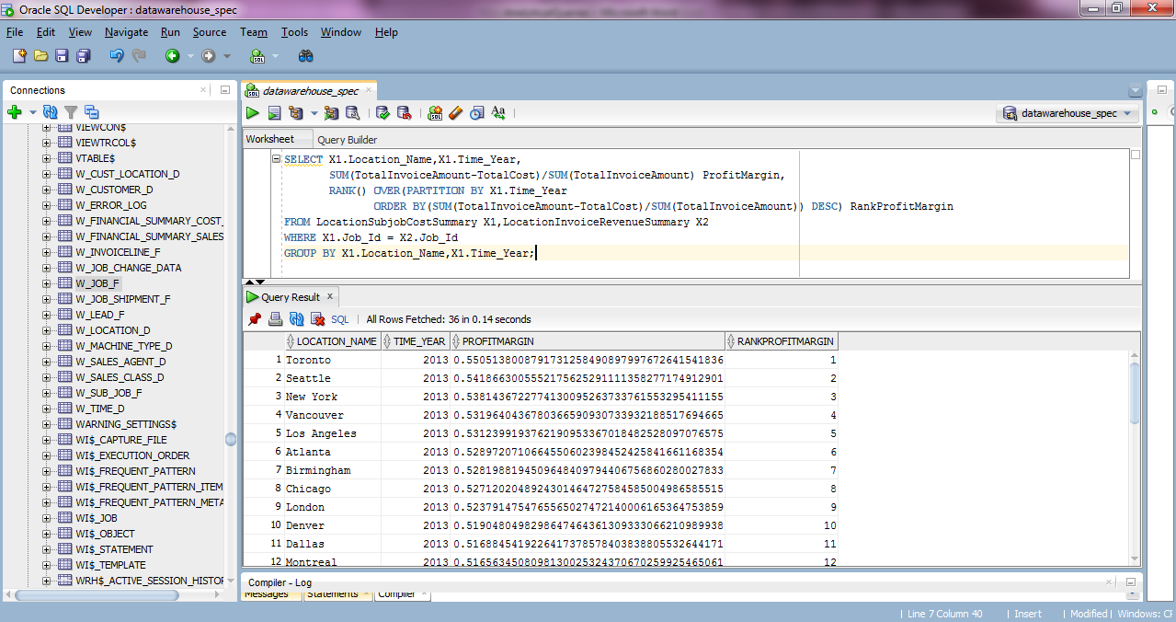

**Analytic Query 5**

SELECT X1.Job_Id,X1.Location_Name,X1.Time_Year,X1.Time_Year,

(TotalInvoiceAmount-TotalCost)/TotalInvoiceAmount ProfitMargin,

PERCENT_RANK() OVER(ORDER BY((TotalInvoiceAmount-TotalCost)/TotalInvoiceAmount)) RankProfitMargin

FROM LocationSubjobCostSummary X1,LocationInvoiceRevenueSummary X2

WHERE X1.Job_Id = X2.Job_Id;

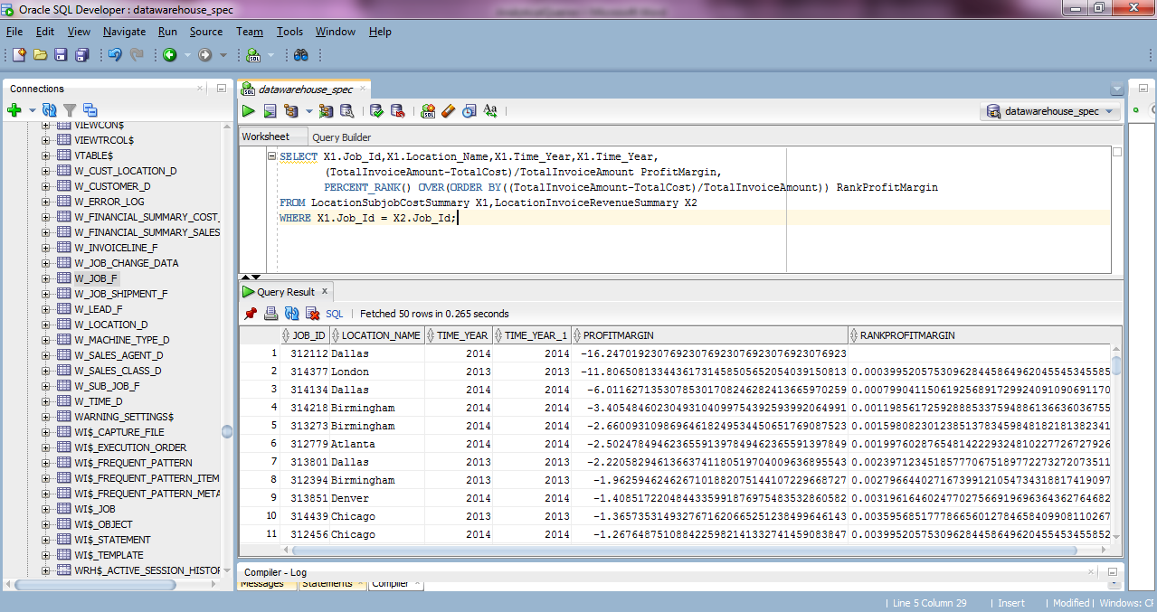

**Analytic Query 6**

SELECT Job_Id,Location_Name,Time_Year,Time_Month,ProfitMargin,PercentProfitMargin

FROM(SELECT X1.Job_Id,X1.Location_Name,X1.Time_Year,X1.Time_Month,

(TotalInvoiceAmount-TotalCost)/TotalInvoiceAmount ProfitMargin,

PERCENT_RANK() OVER(ORDER BY((TotalInvoiceAmount-TotalCost)/TotalInvoiceAmount)) PercentProfitMargin

FROM LocationSubjobCostSummary X1, LocationInvoiceRevenueSummary X2

WHERE X1.Job_Id = X2.Job_Id)

WHERE PercentProfitMargin> 0.95;

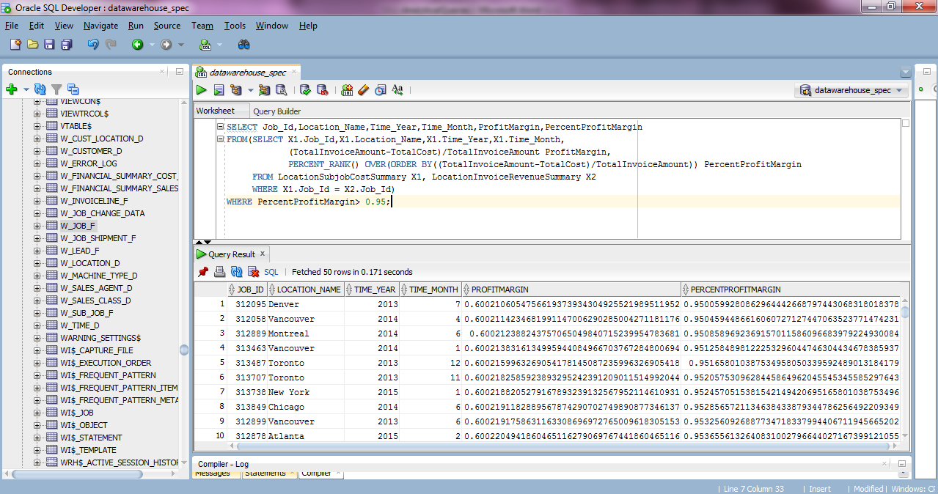

**Analytic Query 7**

SELECT S.Sales_Class_Desc,T.Time_Year,

SUM(I.Quantity_Shipped - I.Invoice_Quantity) ReturnSummary,

RANK() OVER(PARTITION BY T.Time_Year

ORDER BY SUM(I.Quantity_Shipped - I.Invoice_Quantity) DESC) RankReturnSummary

FROM W_Invoiceline_F I

INNER JOIN W_Time_D T ON I.Invoice_Sent_Date = T.Time_Id

INNER JOIN W_Sales_Class_D S ON I.Sales_Class_Id = S.Sales_Class_Id

WHERE I.Quantity_Shipped > I.Invoice_Quantity

GROUP BY S.Sales_Class_Desc,T.Time_Year;

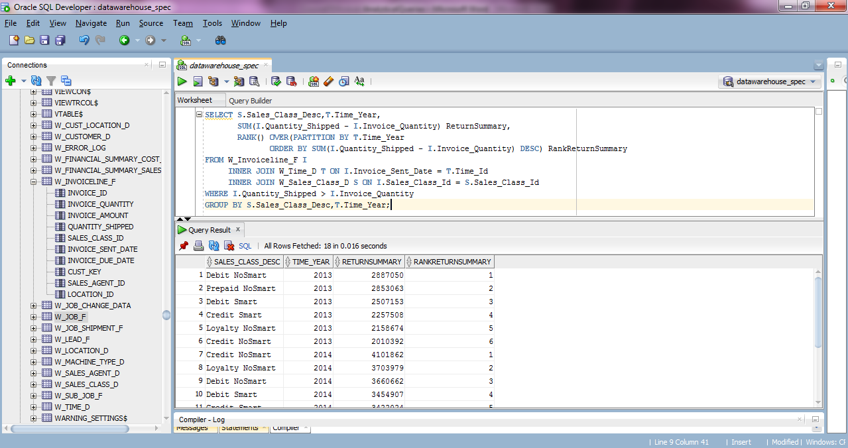

**Analytic Query 8**

SELECT S.Sales_Class_Desc,T.Time_Year,

SUM(I.Quantity_Shipped - I.Invoice_Quantity) ReturnSummary,

RATIO_TO_REPORT(SUM(I.Quantity_Shipped - I.Invoice_Quantity))

OVER(PARTITION BY Time_Year) RatioReturnSummary

FROM W_Invoiceline_F I

INNER JOIN W_Time_D T ON I.Invoice_Sent_Date = T.Time_Id

INNER JOIN W_Sales_Class_D S ON I.Sales_Class_Id = S.Sales_Class_Id

WHERE I.Quantity_Shipped > I.Invoice_Quantity

GROUP BY S.Sales_Class_Desc,T.Time_Year

ORDER BY T.Time_Year,ReturnSummary;

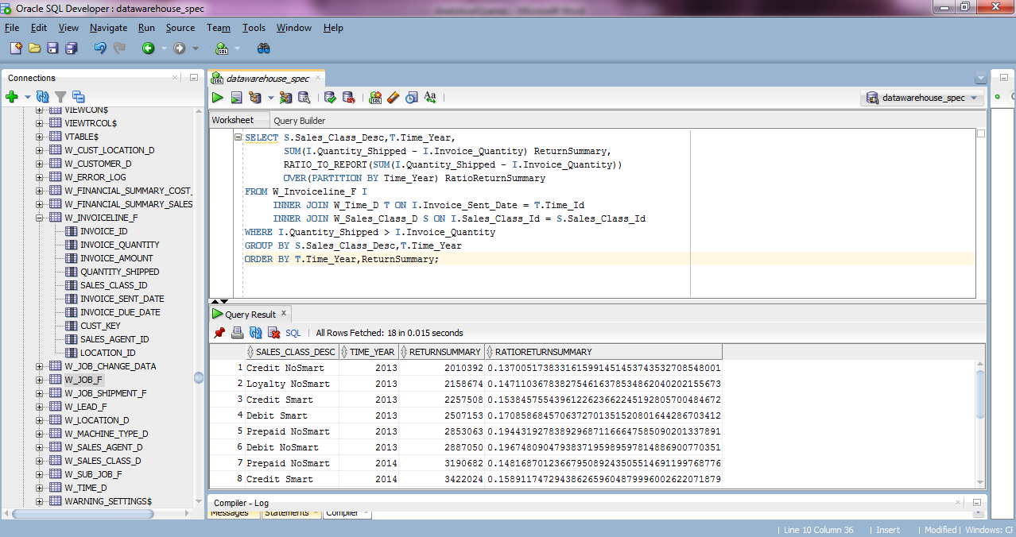

**Analytic Query 9**

SELECT F.Location_Name,T.Time_Year,

SUM(F.BusDaysDiff) SumBusDelayDays,

RANK() OVER(PARTITION BY T.Time_Year

ORDER BY SUM(F.BusDaysDiff) DESC) RankSumBusDelay,

DENSE_RANK() OVER(PARTITION BY T.Time_Year

ORDER BY SUM(F.BusDaysDiff) DESC) DenseRankSumBusDelay

FROM FirstShipmentDelays F,W_Time_D T

WHERE F.Date_Ship_By = T.Time_Id

GROUP BY F.Location_Name, T.Time_Year;

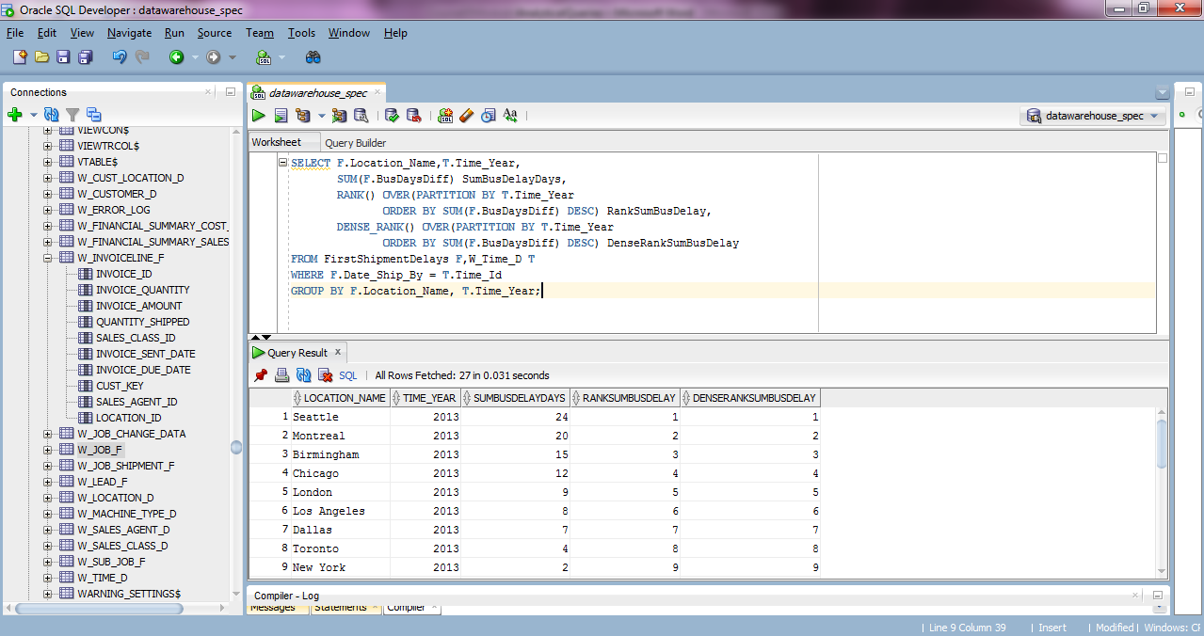

**Analytic Query 10**

SELECT L.Location_Name, T.Time_Year,

COUNT(*) DelayedJobsCount,

SUM(L.BusDaysDiff) SumBusDelayDays,

SUM(L.Quantity_Ordered - L.SumDelayShipQty)/SUM(L.Quantity_Ordered) PromisedDelayDate,

RANK() OVER ( PARTITION BY T.Time_Year

ORDER BY SUM(L.Quantity_Ordered - L.SumDelayShipQty)/SUM(L.Quantity_Ordered) DESC) RankDelayDate

FROM LastShipmentDelays L, W_Time_D T

WHERE L.Date_Promised = T.Time_Id

GROUP BY L.Location_Name, T.Time_Year;

